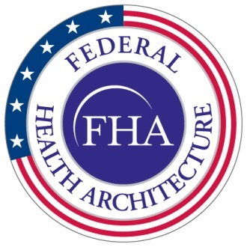 | Office of the National Coordinator for Health IT  Federal Health Architecture  Program Management Office
FHA Federal Health Information Model
(FHIM)
Information Modeling Process Guide

Version 1.0
9/1/14

Contents
TOC \t "Heading 1 A, 1,Title2, 2"
- Background PAGEREF _Toc \h 3
- Scope PAGEREF _Toc1 \h 5
- Information Requirements PAGEREF _Toc2 \h 5
- Domain Assumptions PAGEREF _Toc3 \h 6
- Implementation Requirements PAGEREF _Toc4 \h 6
- Style PAGEREF _Toc5 \h 7
- Approach PAGEREF _Toc6 \h 7

- Background

The healthcare industry has lagged other industries in the application of information technology. This is partly a direct result of the complexity of the subject, but specifically a result of how that complexity retards interoperability. The creation of a particular asset bears an intrinsic cost, but when we add to that cost the effort required to make the asset comprehensible to an outside party, we add a real and immediate cost in anticipation of a benefit that is deferred, unclear, and possibly to the profit of some other party.
The use of data standards ameliorates this problem by providing a common framework for semantic interoperability. If an asset is developed within the standard’s constraints, it is already comprehensible to any partner who shares a commitment to the standard.
It is with this benefit in mind that the Federal Enterprise Architecture (FEA) directs each Federal Agency to produce a Data Reference Model (DRM), and federal agencies are actively building Enterprise Information Models in order to foster interoperability, consistency, efficiency, data quality and transparency within their jurisdictions. And this is a good thing, as far as it goes. But it does nothing to foster interoperability between the agencies. So, in order to minimize duplicate efforts, conserve scarce modeling talent, and foster quality and interoperability, the Office of the National Coordinator has established a single crosscutting modeling effort, whereby existing agency or department modeling efforts can collaborate to refine their models individually, and to achieve consensus on a set of more universal models.
That effort is the Federal Health Information Modeling and Standards program, or FHIMS, and its key product is the Federal Health Information Model, or FHIM. Of the desired features (consistency, efficiency, data quality, transparency, and interoperability), the key supporting requirement is a common way to represent exchanged information. Commonly understood formats support transparency and interoperability among stakeholders, increasing efficiency by reducing translation and transformation efforts, and increasing quality by making errors easy to identify according to shared expectations. Agencies may require data elements in addition to those agreed to in a common format and they may add such elements to FHIM specifications for internal use; the FHIM will only include those elements required for interagency exchange.
In order for the FHIM to support interoperability, it must not only specify common requirements, but it must do so in formats that the stakeholder agencies can understand and use. Consequently, the FHIM is built using industry accepted tools and practices. For information modeling, the Unified Modeling Language (UML) is the industry standard. UML is a multi-purpose language with various diagrams and constructs specialized to describe various aspects of software development and deployment. For information modeling, only one of these diagrams, the class diagram is needed. Of importance to the federal government is that UML is an open standard (stewarded by the Object Management Group, or OMG), and that it is widely supported by both commercial and open-source tools.
It is also advantageous that the federal information models be aligned with the healthcare IT industry models. This is somewhat problematic as the various SDOs are at varying levels of maturity with respect to their own modeling efforts. HL7 arguably has the most extensive modeling experience, but have only recently embraced UML. ASC X12 has targeted an XML platform based on UN/CEFACT constructs. They have a “modeling” methodology called Context Inspired Component Architecture (CICA), but it is not supported by commercial tools. Other SDOs have no formal models, yet important semantics exist in their artifacts; these need to be expressed as models.
As HL7 moves to UML, a series of UML plugins have been developed in open source under the auspices of Open Health Tools which enforce the model constraints and business semantics that are inherent in HL7’s methodology. By moving to UML, HL7 can leverage its extensive clinical expertise in a technological paradigm that supports more than just messaging, but can support document architecture, service “payloads”, etc. The fact that the models are now in UML enables new uses of the artifacts to include code generation, and eventually service interface generation, which can lead to testing and conformance harnesses, etc. Other SDOs, such as NCPDP, are now actively using these tools for their own model development.
It is therefore natural that to the extent practical, the federal information models be constructed using the same tools and the same modeling style. Where the style must diverge in order to meet federal-specific requirements, there should ideally be a mechanism by which the models can be transformed into those that can be consumed and vetted by the SDOs.
A key objective is to follow the principles of the OMG’s Model Driven Architecture (MDA), and develop the model as a Computationally Independent Model (CIM). This will ensure that from the CIM, a standardized, repeatable transformation process can be used to create other models or information artifacts that are optimized for various purposes. In other words, the federal information model is not platform specific; instead, it concentrates on business semantics.

- Scope

The Federal Health Information Model exists to support the exchange of health information among federal agencies and their partners. Actors include federal agencies and partners that exchange health information with them.
Exchange includes the following example use cases:
- A patient is transferred from a DoD facility to a VA facility
- IHS bills VA for treatment of a veteran
- VA sends an infectious disease report to the CDC
- A pharmaceutical firm provides an adverse event report to the FDA
- A VA patient is referred to a doctor at a private clinic
Note that each of these interactions has complex systems at each end, but that all of the data managed by those systems is not the concern of FHIM. FHIM scope is the interoperability specification: information that remains within the walls of an agency or partner is not to be modeled.
In addition to the business scope of these cases, there will be technical constraints. The CDC accepts infectious disease reports as HL7 CDA documents, so the FHIM should be able to generate the report implementation guide for that format. Other formats—NEIM, HL7 V2, NETSS—may also be needed, but each format requires its own implementation guide. FHIM is currently capable of generating CDA and NIEM specifications, and will be enhanced to provide other kinds of specifications as requirements dictate.
- Information Requirements

The key determinant of information requirements is whether an agency requires an element for interoperability.
Requirements are drawn from several sources. The baseline model is the Veterans Administration Health Information Model, or VHIM. Stakeholders may identify requirements specific to their agencies. A key source of requirements is extant standards, including HL7 version 2 specifications. These specifications are in widespread use, and any future-state modeling effort must take legacy compatibility into account. Data elements specified in HITSP publications are retained, absent a compelling reason to exclude or modify them.
While future-state requirements do find their way into the process, the FHIM is not a process re-engineering project. Additional properties may be added prospectively, but without confirmation that they will be of real value, such additions are rare.
With the exceptions of HITSP and Meaningful Use, the criterion for including elements from any of these sources is the assertion by a participant from a stakeholder agency that it is required for interoperability with a partner.
- Domain Assumptions

Domain boundaries are drawn in order to facilitate the modeling process and to make it easier for stakeholders to review items of interest, without having to sift through the entire model.
Domains are created and reviewed serially. Several domains may be in process at once, but a domain can be published without requiring the whole FHIM to be complete.
The initial draft of the FHIM is based on the Veterans Affairs’ Health Information Model, or VHIM. Where changes have been suggested persuasively, domain boundaries have been modified.

- Implementation Requirements

In addition to the subject matter, the FHIM supports requirements for usage. The purpose of the FHIM is to support inter-agency exchange. In order to support exchange, the FHIM leverages Model Driven Health Tools (MDHT) to create specifications. MDHT is built on the ECORE architecture, using UML to generate implementable code: Java, XML, or other technologies as they are identified as priorities. As a result, once the logical modeling is done, specifications can be generated programmatically, enhancing both the efficiency of the process and the quality of the results.
Agencies can compose interface packages in the FHIM, using the agreed data elements and model structure, and selecting a specific implementation platform. A specification will consist of
- A package defining the scope of the interaction, including which partners participate
- A use case, describing the interaction and specifying the data elements in scope and any further constraints (e.g., selection from available terminologies)
- Designation of one or more implementation platforms (CDA, NIEM, etc.)
- The specification generated by the FHIM’s MDHT tool
The FHIM must be capable of modeling the required business content and generating the platform-specific guide for the cases it supports.

- Style

There is a style guide that specifies naming conventions, class patterns, and other tactical modeling decisions. That guide is intended to ensure that different modelers produce similar work products, both so that the required level of detail is clear to the modeler and so that reviewers can learn a single set of assumptions, and not have to worry about whether things that look different look that way because of underlying content or because of stylistic variation.

- Approach

The FHIM approach to modeling a domain is outlined in figure 1.
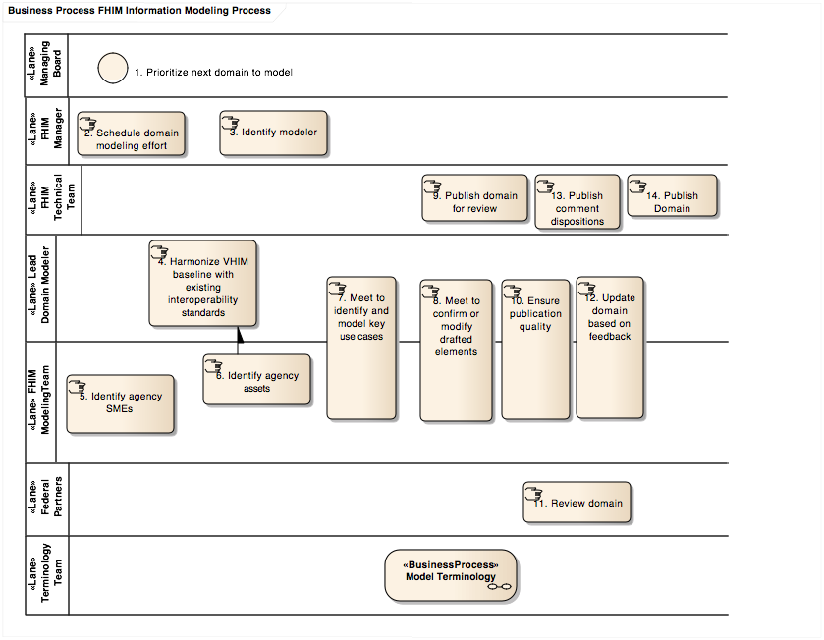
Figure 1: FHIM Information Modeling Process
Process Steps
- The Managing board determines which domains are prioritized for near-term modeling.
- The Manager, working with input from the team, determines when the effort will begin.
- The Manager also identifies the lead modeler for the domain, who will be responsible for updating the model to reflect the consensus of the modeling team.
- The lead modeler harmonizes the baseline FHIM (copied from the VHIM) with current interoperability specifications from HL7 V2, HITSP, and Standards & Interoperability Framework.
- The modeling team also identifies key subject matter experts (SMEs) from their respective agencies who should participate in the modeling effort.
- These SMEs may provide additional content to the lead domain modeler, who may include it in the pre-meeting harmonization work, or may defer that activity to the meetings, where agency-specific requirements can be explained.
- The first meetings of the modeling team will define the scope of the modeling effort by identifying the use cases the model should support. These cases are not modeled in detail, but they are given names, boundaries, and participants, so that the information modeling effort will be informed by a clear understanding of purpose. In general, this means cases that require interoperability among agencies and their partners.
  - As agencies begin using the FHIM, they will detail use cases to scope their interactions, and they will be added to the model at that point. The use case packages will further constrain FHIM classes and properties, and will define their transformation into specifications. See the Implementation Guide for more details.
- Subsequent meetings focus on moving toward consensus on the updated FHIM domain, contributing new requirements or refinements in meeting sessions as necessary. Every information element in the FHIM should have at least one reference to a requirement, whether it be an agency model (like the VHIM), a standard (like a HITSP reference to an HL7 V2 field), or some other specifically identified need. In addition, as the baseline model is a version of the VA’s VHIM, elements not required in any inter-agency exchange are removed.
  - The terminology modeling effort is conducted in parallel, with a slight lag, so that the information modeling team can provide the terminology team with the right set of coded data elements to model, but the terminology team has the opportunity to provide feedback on those element definitions. See the companion Terminology Modeling document for details.
- Once the team agrees that the domain is complete, the technical team publishes the model in a format suitable for review.
- The modeling team reviews the publication to ensure it will provide the clearest possible presentation of the FHIM domain to the agency partners.
- The model is distributed to partner agencies for review, with instructions on how to provide feedback.
- The modeling team reviews the comments. Some will result in changes to the model.
- Some comments may indicate a misunderstanding or other issue that should not result in a change to the model. These are addressed in a comment disposition repository; dispositions are also shared directly with the commenters.
- The revised model is published on the FHIMS.org website.
  - The domain remains available for modification, but there is a baselined, versioned publication that stakeholders can use for specification development.
Specification development is a separate process, detailed in the Implementation document. It involves selecting a specific interaction and technical platform, identifying the FHIM elements necessary to support that interaction, and ensuring that the UML profile for the target platform converts the FHIM elements correctly.
In addition to harvesting useful models from the SDOs and SROs, the FHIMS information modeling effort will bring changes and new content to the SDOs and SROs based on materials derived from this work. Many of the federal partners are already active in the industry bodies; this effort affords an opportunity for the partners to determine federal requirements internally, and then to present a consistent set of requirements to the industry bodies.

See www.uml.org
See www.omg.org
See www.openhealthtools.org

